
PRESS RELEASE Ostrava, 24th May 2017

Further spaces occupied in Nová Karolina Park
The Nová Karolina Park office project in Ostrava has expanded its portfolio of tenants to include The IT centres Stora Enso - SDCC Ostrava (Software Development Competence Center) and Y Soft Corporation, a.s., which provides solutions for the management of printing and digitalisation. Stora Enso placed its service centre for the development and maintenance of IT systems for all of its company’s branches worldwide in more than 2500 m2 on the entire fifth storey of the southern part of the building. Y Soft Corporation occupied 690 m2 of office space, where it set up its development centre and customer support centre. Moreover, UniCredit Bank and ABB both expanded their offices here this year.
PASSERINVEST GROUP’s Nová Karolina Park office building went up on a site that has its genius loci and every civic amenity and excellent parking opportunities. Both its location on Ostrava’s busy 28. října Street with a tram stop right by the building’s north reception and its atrium leading to the Forum Nová Karolina shopping centre increase its attractiveness.
“The project has always interested us, we were able to see it from the old offices right from the beginning, and when the decision about the new spaces for further expansion was made. It was the preferred option, both from the employees’ perspective, being in the centre with good traffic accessibility, and for the company, with its environmental certification, prestigious location, placement of all the employees on one floor, the adaptation of the spaces to fit our needs and the opportunity for further expansion,” stated Marián Drozd, the Site Manager of Stora Enso.
Stora Enso - SDCC Ostrava (Software Development Competence Center) was founded in 2006 and currently specialises primarily in the development of logistics and sales system for its production and sales areas. With its 190 employees, Ostrava’s Stora Enso – SDCC is the company’s largest development centre.
Y Soft Corporation, a.s., was founded in 2000 in Brno and today the company has branches throughout the world. Y Soft is a leading supplier on the international market in the area of print management and control, and document digitalisation. The solution, based on the YSoft SafeQ platform, helps businesses optimise operating expenses and increase employee productivity. Y Soft currently employs 370 people, 43% of which are involved in research and development.

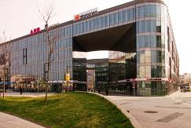

Building Nová Karolina Park

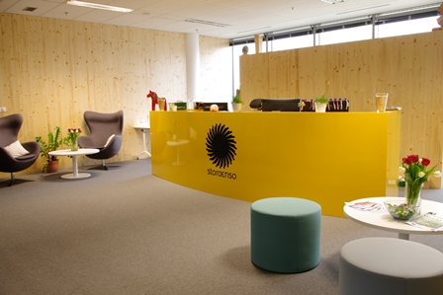

Reception of the new Stora Enso - SDCC Ostrava service centre on the fifth floor of the Nová Karolina Park building

ABOUT THE NOVÁ KAROLINA PARK PROJECT
The Nová Karolina Park office building is sensitively located in a newly-urbanised area of Ostrava near Masarykovo náměstí and it forms a “gateway” from the historic core of the city. The developer of the project is a joint venture between PASSERINVEST GROUP and GEMO OLOMOUC. The project’s architectural design comes from the drawing boards of Vít Máslo and David R. Chisholm of CMC architects. The entire project is spread out over 32 hectares of space on six storeys and it offers almost 24,600 m² of prime office space. This is supplemented on the ground floor with 3700 m² of space suitable for shops, services and restaurants. There are 279 underground parking spaces meant for the users of the building. Nová Karolina Park is certified as a green building according to BREEAM (BRE Environmental Assessment Method). The British BREEAM certificate is a prestigious methodology for the certification of green buildings in Europe.

PASSERINVEST GROUP, a. s., is a purely Czech development company, whose name is primarily connected with the construction of the multifunctional BB Centrum complex in Prague 4 – Michle. The company, founded in 1991 by Radim Passer, built a very good name on both a domestic and international level with this, the most successful and extensive Czech project of its kind. This is not only due to the quality of the implemented projects and the high level of provided services, but also to a sense of fair play, an accommodating relationship with the tenants/users of the buildings and the responsibility towards society and the environment. PASSERINVEST GROUP also has other interesting development projects in its portfolio.

For more information and photographs in print quality please contact:
Kristýna Samková, Head of PR and Marketing dept.
PASSERINVEST GROUP, a.s.
Tel.: (+420) 221 582 111
Mobil: (+420) 602 186 708
E-mail: Kristyna.Samkova@Passerinvest.cz
www.passerinvest.cz, www.bbcentrum.cz

Marcela Štefcová
Crest Communications a.s.
Mobile: (+420) 731 613 669
E-mail: marcela.stefcova@crestcom.cz
www.crestcom.cz

